**PROJECT REPORT**

**ON**

***“Deep learning Models on EEG Data using BCI”***

Submitted in partial fulfilment of the

Requirement for the award of the degree of

**Bachelor of Computer Application**

** **

**Submitted sTo Submitted By**

**Dr Neha Goel Vaibhav Baweja**

**Assistant Professor 13817702018**

**BCA 5-C**

(Batch: 2018-2021)

**Vivekananda Institute of Professional Studies**

**(Affiliated to Guru Gobind Singh Indraprastha University)**

**CERTIFICATE**

This is to certify that Vaibhav Baweja of BCA 5th Semester from Vivekananda Institute of Professional Studies, Delhi has presented this project work entitled “Deep learning Models on EEG ”, an online auction website in partial fulfilment of the requirements for the award of the degree of Bachelor of Computer Applications under our supervision and guidance.

Dr Neha Goel

Associate Professor

**ACKNOWLEDGEMENT**

My internship experience at Institute of Nuclear Medicine and Allied Sciences, Defence Research and Development Organisation (INMAS-DRDO) as a research intern from July 2020 to November 2020 was an enriching one. The time I spent a memorable one for me as it was rich in experience sharing and helped me discover my potential. I have had so many rich experiences and opportunities that I personally believe will forever shape and influence my professional life while fostering personal growth and development. I am using this opportunity to express my deepest gratitude and special thanks to our mentor, Mr. Vishal Pandey, who in spite of being extraordinarily busy with his duties, took time out to hear, guide and keep me on the correct path and allowing me to carry out my project at their esteemed organization and extending during the training. I perceive this opportunity as a big milestone in my career development. I will strive to use gained skills and knowledge in the best possible way, and I will continue to work on their improvement, in order to attain desired career objectives. Hope to continue cooperation with all of you in the future.

Vaibhav Baweja

|  |  |
| --- | --- |
| **Table of Contents** | **Page No.** |
| 1. **INTRODUCTION**    1. **Objective of the System**    2. **Justification and need for the system**    3. **Advantage of the system**   **1.4 Previous work or related systems, how they are used.**  **2 DATA LOADING AND PREPROCESSING-TRIAL WISE DECODING**    **2.1 Load data**   * 1. **Preprocess Data**   2. **Cut compute window**     **3 SPLITTING THE DATASET AND CREATING MODEL-TRIAL WISE DECODING**   * 1. **Split the data**   2. **Model made**   **4 TRAINING AND PLOTING RESULTS-TRIAL WISE DCODING**   * 1. **Training**   2. **Plotting results**   **5 LOADING AND PREPROCESSING DATA-CROPPED DECODING**   * 1. **Software Testing and Objective of Testing**   **5.2 Sample test data/ Output screen printouts etc.**  **6 MODEL AND COMPUTE WINDOW PARAMETERS-CROPPED DECODING**   * 1. **Compute window parameter**   2. **Model**   **7 ADDITIONAL TOUCHES TO MODEL-CROPPED DECODING**  **7.1Transforming model**  **7.2Cut the data into windows**  **8 SPLIT THE DATASET AND FIT THE MODEL**  **9 RESULTS**  **10 CONCLUSION** | 5  6  6  7  8  9  9  10  11  12  12  13  14  15  16  17  18  19  20  21  22  23 |

**Chapter 1**

**INTRODUCTION**

An electroencephalogram (EEG) is a test used to evaluate the electrical activity in the brain. Brain cells communicate with each other through electrical impulses. An EEG can be used to help detect potential problems associated with this activity. An EEG tracks and records brain wave patterns. Electroencephalographic activity is measured by placing electrodes at different locations over the scalp. The signals are measured as the difference in voltage between two electrodes (usually one is a reference for all other electrodes). Measuring the activation of a specific brain region requires placing electrodes as close as possible to that area, and therefore electrodes placed at different cortical positions allow measuring different neural processes. EEG-based BCI systems rely on detecting changes in the brain patterns produced as a response to some voluntary or involuntary mental command.

**What is BCI?**

Brain Computer Interface is a communication pathway between wired brain and an external device. BCIs are often directed at researching, mapping, assisting, augmenting or repairing human cognitive or sensory-motor functions

**What is motor imagery?**

Motor imagery is a mental process by which an individual rehearses or simulates a given action. This type of phenomenal experience implies that the subject feels themselves performing the action. The data obtained while motor imagery task is divided in various classes depending the task the person is doing.

**1.1 OBJECTIVE OF THE SYSTEM**

This project will serve the following objectives:-

1. Training on EEG dataset which can be used in motor movements in another system
2. Effectively extracting EEG data features in Brain Computer Interface technology.
3. An end-to-end novel hybrid deep learning scheme is developed to decode MI task from EEG data.
4. Achieve training and validation accuracy
5. Understanding the process of decoding
6. Understanding functionalities of libraries such as brain decode and pytorch.

**1.2 JUSTIFICATION AND NEED FOR THE SYSTEM**

Physically disabled people have suffered from centuries, with advancement in science we have helped them in various manners. With the advent of EEG and BCI technologies we can help them control cars and UAVs with imagined movements. Applying deep learning models on dataset after filtering and processing data helps in learning the imagined movements the subject did during trial so that we can create real time systems to control UAVs and cars for them. Such a system will learn on the features of EEG which will be useful for disabled people.

**1.3 Advantages of the system**

1. **Easiness in modification of data**: The proposed system provides managing of huge data effectively and efficiently for efficient results, storing the details of the products, users, etc. in such a way that the database can be modified.

2. **User friendly**: The proposed system is user friendly because the retrieval and storing of data is fast and data is maintained efficiently. Moreover the graphical user interface is provided in the proposed system, which provides user to deal with the system very easily.

3. **No or very few paperwork**: The proposed system either does not require paper work or very few paper works is required. All the data is feted into the computer immediately and various feedbacks and reports can be generated through computers. Since all the data is kept in a database no data of the organization can be destroyed. Moreover work becomes very easy because there is no need to keep data on papers.

4. **Support strategic competitive advantage**: Proposed system supports strategic competitive advantages. Since the proposed systems provide easiness in reports generating it will provide strategic advantages among competitors.

5. **Computer operator control**: Computer operator control will be there no errors. Moreover storing and retrieving of information is easy. So work can be done speedily and in time.

**1.4 Previous work or related systems; how they are used.**

Before we begin a new system it is important to study the system that will be improved or replaced (if there is one). We need to analyze how this system uses hardware, software, network and the people resources to convert data resources, such as transaction data, into information products, . Thus we should document how the information system activities of input, processing, output, storage and control are accomplished.

Following are the problems associated with the previous project which led to the creation of the proposed project:-

1.**Inability of modification of data:** The managing of huge data effectively and efficiently for efficient results, storing the details of the products etc. in such a way that the database can be modified as not possible in the current system.

2.**Not user friendly:** The existing system is not user friendly because the retrieval and storing of data is slow and data is not maintained efficiently.

3.**Difficulty in reports generating**: Either no reports generating in a current system or they are generated with great difficulty reports take time to generate in the current system.

4.**Manual operator control:** Manual operator control is there and leads to a lot of chaos and errors.

5.**Lot of paperwork:** Existing system requires lot of paper work and even a small transaction require many papers fill. Moreover any unnatural cause (such as fire in the organization) can destroy all data of the organization. Loss of even a single paper led to difficult situation because all the papers are interrelated.

6**.Inability of sharing the data:** Data cannot be shared in the existing system. This means that no two persons can use the same data in existing system. Also the two departments in an organization cannot interact with each other without the actual movement of data.

7. **No support in decision-making:** Existing system does not support managerial decision-making.

**8.No support in strategic competitive advantage:** Existing system does not support strategic competitive advantages.

**Chapter 2**

**Data Loading and pre-processing-Trial wise Decoding**

We will be using EEG data given by BCI Competition IV 2a in brain-decode which is a deep learning toolbox to decode raw time domain EEG. The dataset is present in MOABB dataset of brain decode tool box. Data loading and preprocessing is highly crucial part of model making .

* 1. **Load Data**

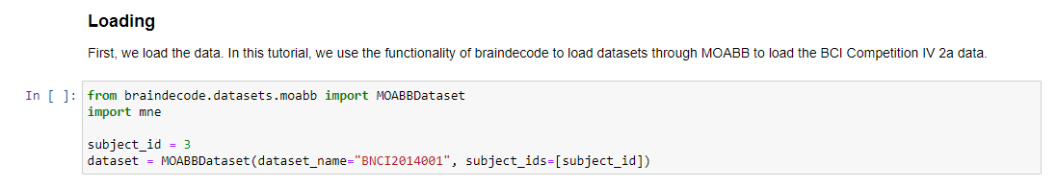

**2.2 Pre-processing the data**

I have used bandpass filtering for preprocessing and functions like MNEpreproc and numpyprepoc are used with band filter length from 4-38 hz.

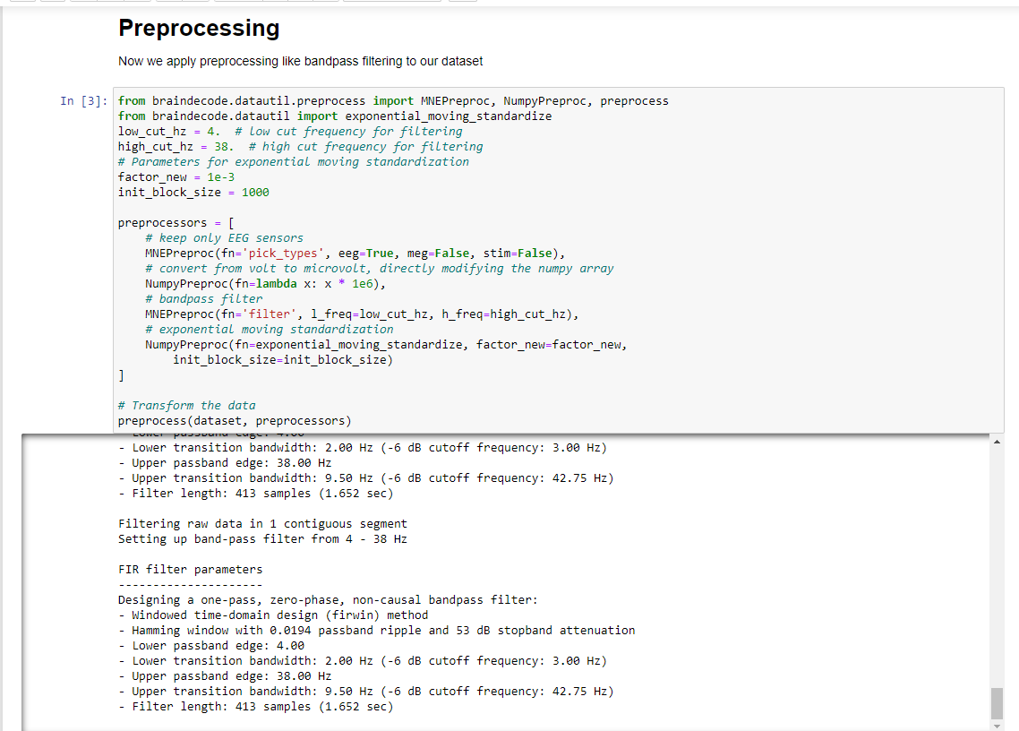

**2.3Cut compute window**

Now we cut out compute windows, the inputs for the deep networks during training. In the case of trialwise decoding, we just have to decide if we want to cut out some part before and/or after the trial. For this dataset, in our work, it often was beneficial to also cut out 500 ms before the trial.

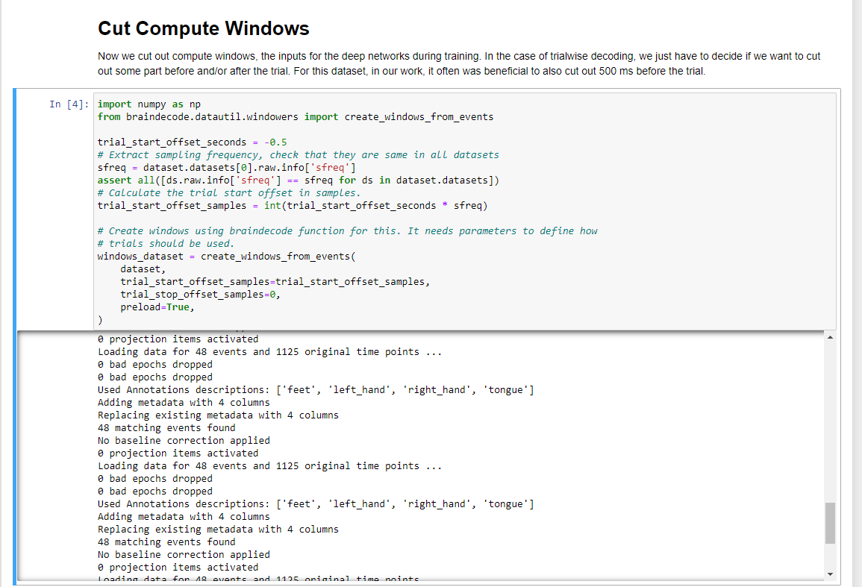

**Chapter 3**

**Splitting dataset and creating model-Trialwisedecoding**

**3.1** **Split dataset into train and valid**

We can easily split the dataset using additional info stored in the description attribute, in this case session column. We select session_T for training and session_E for validation**.**



**3.2 Create Model**

Now we create the deep learning model! Brain decode comes with some predefined convolutional neural network architectures for raw time-domain EEG. Here, we use the shallow Convent model from Deep learning with convolutional neural networks for EEG decoding and visualization. 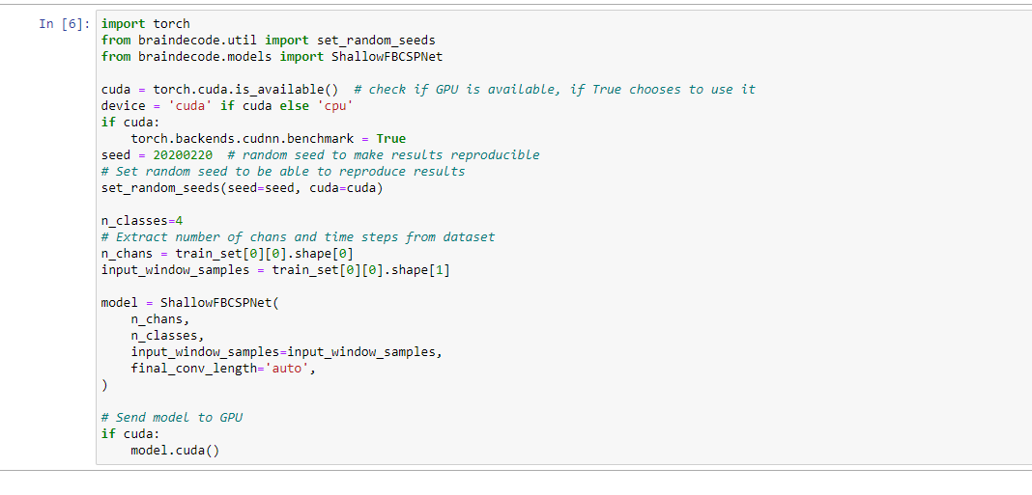

**Chapter 4**

**Training and plotting results-Trialwise decoding**

**4.1Training**



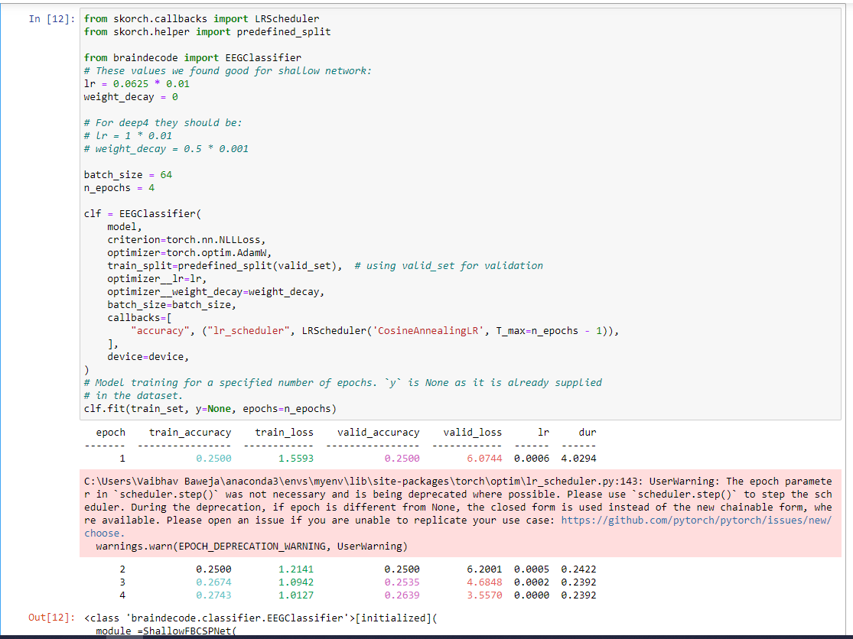

**4.2 Plotting Results**

Now we use the history stored by Skorch throughout training to plot accuracy and loss curves.

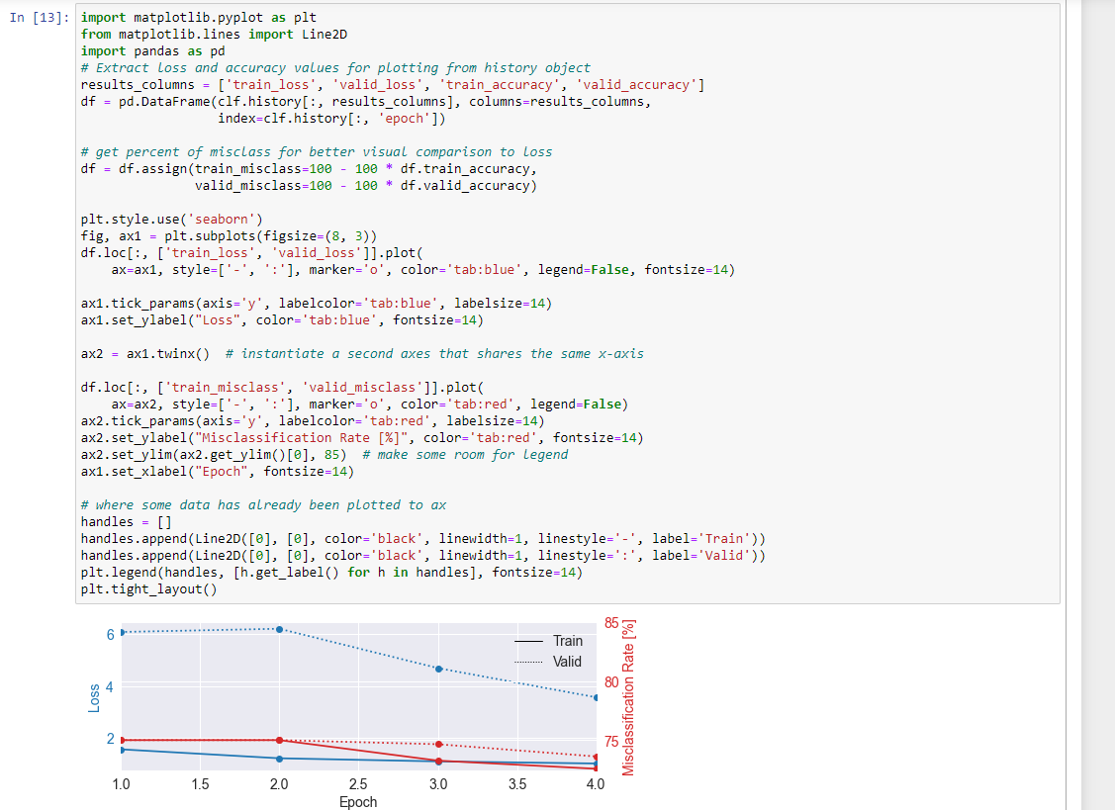

**Chapter 5**

**Loading and Pre-processing data - Cropped Decoding**

* 1. **What is cropped decoding?**

1. Instead of a complete trial, crops are pushed through the network.
2. For computational efficiency, multiple neighboring crops are pushed through the network simultaneously (these neighboring crops are called compute windows)
3. Therefore, the network produces multiple predictions (one per crop in the window)
4. The individual crop predictions are averaged before computing the loss function
   1. **Loading and processing the data using braindecode**

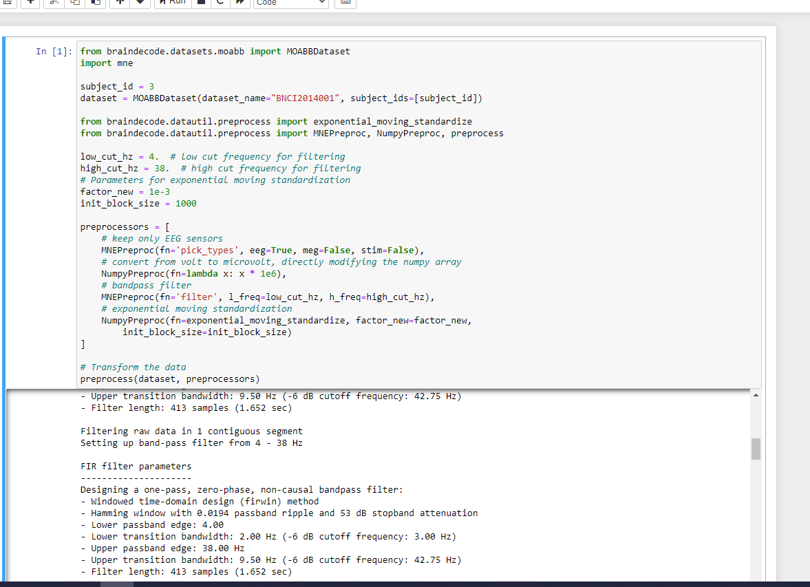

**Chapter 6**

**Model and compute window parameters-Cropped Decoding**

* In contrast to trial wise decoding, we first have to create the model before we can cut the dataset into windows. This is because we need to know the receptive field of the network to know how large the window stride should be.

**6.1 Compute Window parameters**

* We first choose the compute/input window size that will be fed to the network during training This has to be larger than the networks receptive field size and can otherwise be chosen for computational efficiency (see explanations in the beginning of this tutorial). Here we choose 1000 samples, which are 4 seconds for the 250 Hz sampling rate.



* 1. **Model**
* Now we create the model. To enable it to be used in cropped decoding efficiently, we manually set the length of the final convolution layer to some length that makes the receptive field of the ConvNet smaller than input_window_samples
* 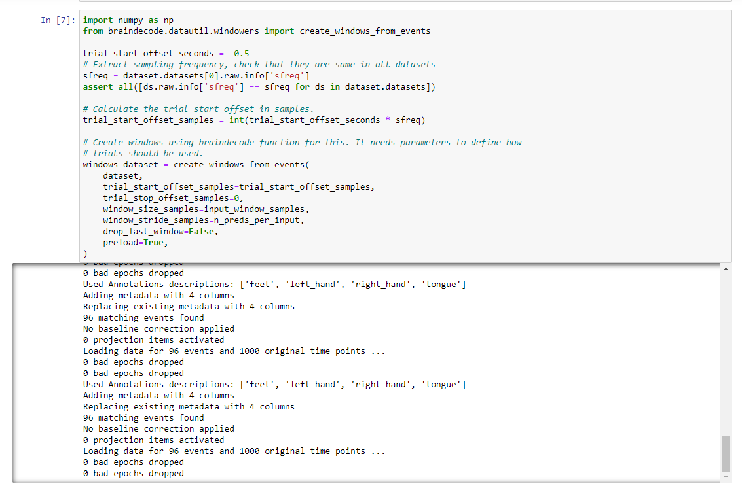

**Chapter 7**

**Additional touches to model-Cropped Decoding**

**7.1 Transforming model**

And now we transform model with strides to a model that outputs dense prediction, so we can use it to obtain predictions for all crops.



To know the models’ receptive field, we calculate the shape of model output for a dummy input.



**7.2 Cut the data into windows**

In contrast to trialwise decoding, we have to supply an explicit window size and window stride to the create_windows_from_events function.

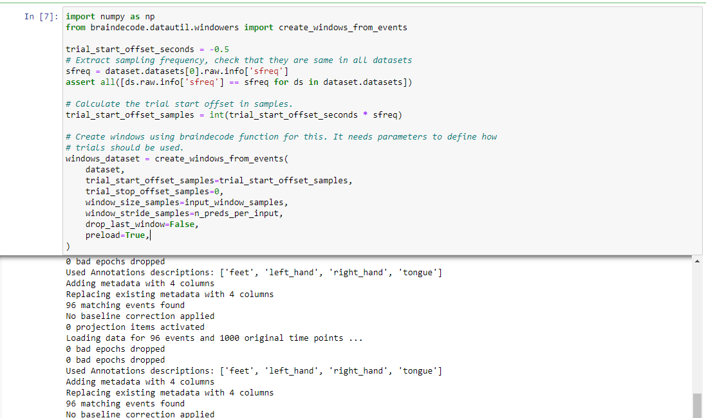

**Chapter 8**

**Split the dataset and fit the model**

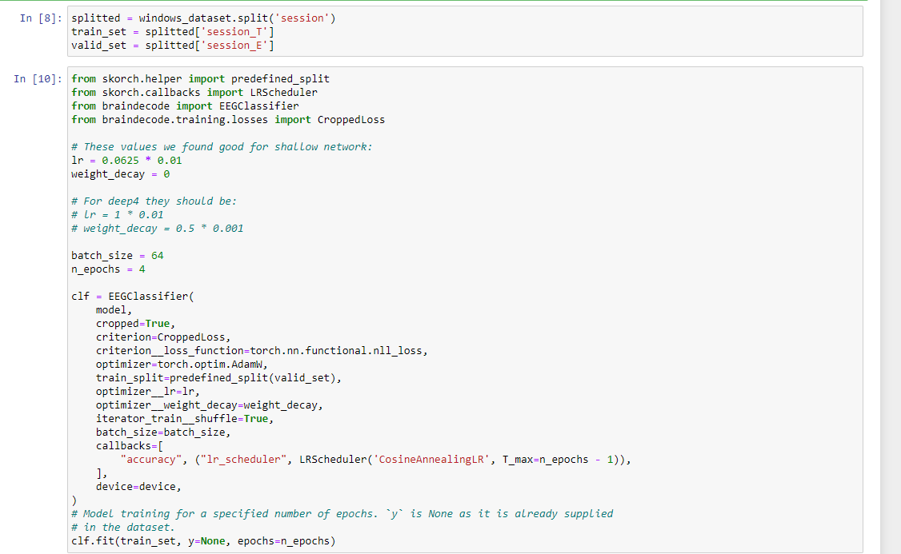

**Chapter 9**

**Results**

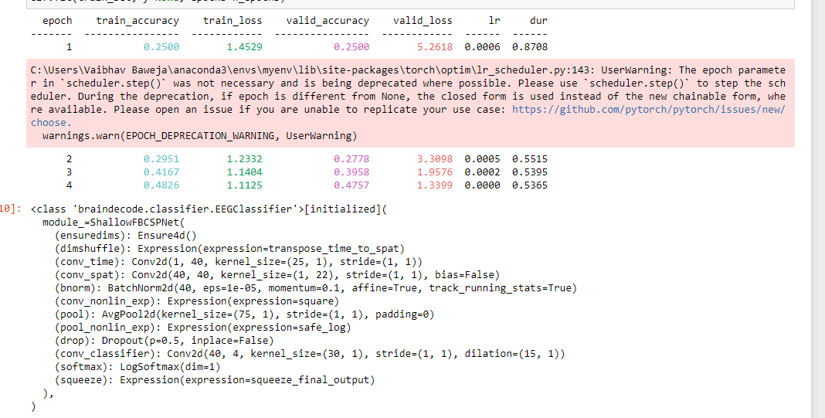

**Plotting the results**

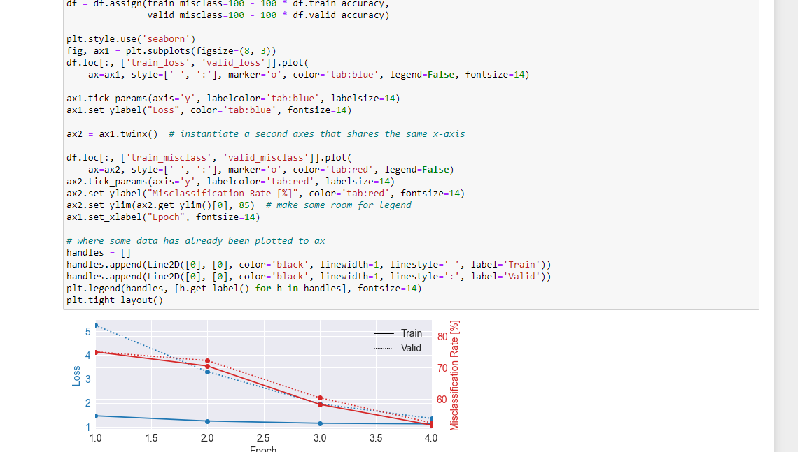

**Chapter 10**

**CONCLUSION**

In Trialwise decoding bandpass filtering is used for pre-processing and functions like MNEpreproc and numpyprepoc are used with band filter length from 4-38 hz.Compute window is cut out, data is split into training and testing and model is made using pytorch. Shallow fbcspnet neural network is used, Finally, trained the model with 4 epochs giving best train accuracy as 0.27 and validation accuracy as 0.2639.

Since the accuracy was low, I tried cropped decoding. Instead of a complete trial, crops are pushed through the network.For computational efficiency, multiple neighboring crops are pushed through the network simultaneously (these neighboring crops are called compute windows)Therefore, the network produces multiple predictions (one per crop in the window).The individual crop predictions are averaged before computing the loss function From this we get the best training accuracy of 0.48 at the fourth epoch and validation accuracy of 0.47 also at 4th epoch.

We conclude that cropped wise decoding gives us better results and can be used further in real time systems to train.

**BIBLOGRAPHY**

* http:// www .stackoverflow.com
* http://wikipedia.com
* https://towardsdatascience.com/